**DEFINE THE PARAMETERS/ARGUMENTS FOR IMAGE**

**DATA GEMERATOR CLASS**

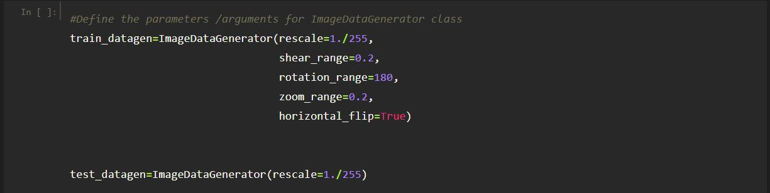

Here the arguments which we are given inside the image data generator class are, rescale, shear_range, rotation range of image, and zoom range that we can consider for images, etc.

* Image shifts via the width_shift_range and height_shift_range arguments.
* Image flips via the horizontal_flip and vertical_flip arguments.
* Image rotations via the rotation_range argument
* Image brightness via the brightness_range argument.
* Image zoom via the zoom_range argument.

We can pass many other arguments inside the ImageDataGenerator Class.

**Parameters should address the following aspects to keep the project overall moving and succeeding.**

1. **Scope:**

Defining North Star. How do we know when the work is done or the game is over? What’s the end goal? Where are the edges of the field?

2)    **Success:**

How are we measuring how well we’ve done when we reach the end? Is it speed, gathering consensus from others or user adoption, optimizing for low cost, etc.?

3)    **Stakeholders and Selves:**

Who are the stakeholders (fans or audience)? Who’s playing the game and who is watching the game? For ourselves: are we dividing the work, or are we working as a team? Do we have enough people for this project with the right mix of skills (players for the game)?

4)    **Strategy and Structure:**

What approach are we using? Are we valuing a methodical process, or a creative process, or somewhere in between?

* **As a project team leader, knowing the answers to these questions ahead of time increases the initial trajectory of the work and enables the project team to start on even ground.**
* If you have been given some flexibility and leeway for the above, you may opt to have a starting point and then a method to get input from the core team, but don’t leave it entirely democratic, or the game may never get started.
* Allocate a specific amount of time to define them, then move forward.
* **you certainly can open up the kick-off meeting by establishing these parameters, and leaving room for the team to collaborate on any additional double-click rules they want to establish for working together.**
* Often, additional parameters tend to fall under the above, however enabling the team to create them together will get you buy-in and increase individual autonomy and ownership- critical for engagement and prioritization of this work, and ultimately, higher quality work.